CHAPTER 1

INTRODUCTION

In today’s world, every benefit or service of technology being enjoyed by the mankind is because every

service was once a plan and a project. One of the rudimentary reasons for those projects to succeed or fail

was the amount of quantitative and qualitative data there were processing on. These Company projects also serve as an important information extractor for any future projects in that particular domain to be undertaken.

There are so many Companies in today’s world that are undertaking various projects in plenty of fields, it is difficult to keep the track of future and as well as accomplished projects and analyse them over their benefits, status, history etc.

This project, “COMPANY PROJECTS AND ANALYTICS “ enables to systematically organise the data regarding various Company projects that are being undertaken or already accomplished.

It also contains effective relevant data that can be used for further interpretations and analysis thereby acting as an information extractor especially for Entrepreneurs and Business Owners.

Objectives of the project

The main objectives behind the development of this project are as follows:

1. To make data of various on-going and accomplished projects available in one repository.
2. To provide an option to manage and view data in an efficient manner.
3. Any Company can keep track of their on-going projects and take decisions accordingly.
4. System displayed data can be used decide the course of the project and to take administrative decisions.
5. It also gives a brief overall overview of the trend in Technology and relevant Companies and their services.
6. Provides an easy and secure interface acting like an automated assistance.

Thus there is a number of objectives behind developing the “COMPANY PROJECTS AND ANALYTICS”.

CHAPTER 2

SYSTEM REQUIREMENTS

2.1. SOFTWARE REQUIREMENTS

* Operating system : windows 8.1
* Database : MySQL
* Language : HTML,CSS,JAVASCRIPT,PHP

2.2. HARDWARE REQUIREMENTS

* RAM : 256 MB
* HARD DISK : 2GB
* 1 Printer
* Other related peripherals

CHAPTER 3

PROBLEM DESCRIPTION

COMPANY PROJECTS AND ANALYTICS

Mr. VAIBHAV is a Business Strategist and has to serve his clients for shaping their Business needs. He always wants to keep himself updated regarding various on-going and accomplished projects so that he can utilize the systematic information to help his clients. Thus he constantly keeps track and maintains his personalized information through COMPANY PROJECTS AND ANALYTICS system. This system consists of the following tables,

* USER LOGIN
* PROJECT DETAILS
* FOUNDER DETAILS
* PARENT COMPANY DETAILS
* PROJECT DESCRIPTION
* FIGURE DETAILS
* TRIGGER TIME

All the tables are normalized into 1NF, 2NF and 3NF.

USER LOGIN

Table name: LOGININFO

Description: To store login information of users.

|  |  |  |  |  |
| --- | --- | --- | --- | --- |
| Field name | Data Type | Size | Constraints | Description |
| EMAIL | Varchar | 100 | Not Null | User Email |
| USERNAME | Varchar | 100 | Primary Key | Username |
| PASSWORD | Varchar | 100 | Not Null | User Password |

3.1. Admin login table

PROJECT DETAILS

Table name: PROJECT_DETAILS

Description: To store various Project Information.

|  |  |  |  |  |
| --- | --- | --- | --- | --- |
| Field name | DataType | Size | Constraint | Description |
| PID | Int | 5 | Primary Key, Foreign Key | Project Identity |
| PNAME | Varchar | 100 | Not Null | Project name |
| PDESC | Varchar | 100 | Not Null | Project Description |
| PCAT | Numeric | 100 | Null | Project Category |
| PLOC | Varchar | 100 | Null | Project Location |
| PRATING | Varchar | 100 | Null | Project Rating |
| START_DATE | Varchar | 100 | Null | Project Start Date |
| STATUS | Varchar | 100 | Null | Project Status |

3.2. Project Details Table

FOUNDER DETAILS

Table name: FOUNDER

Description: To store Project Founder Details.

|  |  |  |  |  |
| --- | --- | --- | --- | --- |
| Field name | DataType | Size | Constraint | Description |
| FID | Int | 5 | Primary Key, Foreign Key | Founder Identity |
| PFNAME | Varchar | 100 | Not Null | Project Founder Name |
| PFTEAMNAME | Varchar | 100 | Null | Project Team Name |

3.3. Founder Table

PARENT COMPANY DETAILS

Table name: PARENT_COMPANY

Description: To store Parent company information

|  |  |  |  |  |
| --- | --- | --- | --- | --- |
| Field name | DataType | Size | Constraint | Description |
| PID | Int | 5 | Primary Key | Project Identity |
| FID | Int | 5 | Primary Key | Founder Identity |
| PAREN_COM | Varchar | 100 | Not Null | Parent Company |
| PAREN_CAT | Varchar | 100 | Null | Parent Category |
| PAREN_LOCATION | Varchar | 100 | Null | Parent Location |
| FNAME | Varchar | 100 | Null | Founder Name |
| FPORTFOLIO | Varchar | 100 | Null | Founder Portfolio |

3.4. Parent Company table

PROJECT DESCRIPTION DETAILS

Table name: PDESCRIPTION

Description: To store purchase information

|  |  |  |  |  |
| --- | --- | --- | --- | --- |
| Field name | Data Type | Size | Constraint | Description |
| PID | Int | 5 | Primary Key | Project Identity |
| PDESCRIP | Varchar | 1000 | Null | Project Description |
| PAPP | Varchar | 1000 | Null | Project Applications |
| PCHAL | Varchar | 1000 | Null | Project Challenges |

3.5. Project Description

FIGURE DETAILS

Table name: FIGURES

Description: To store supplied information

|  |  |  |  |  |
| --- | --- | --- | --- | --- |
| Field name | Data Type | Size | Constraint | Description |
| PID | Int | 5 | Primary Key | Project Identity |
| FID | Int | 5 | Primary Key | Founder Identity |
| PCOST | Varchar | 100 | Null | Project Cost |
| PAREN_VAL | Varchar | 100 | Null | Project Valuation |

3.6. Figure table

TRIGGER TIME

Table name: TGTIME

Description: To store supplied information

|  |  |  |  |  |
| --- | --- | --- | --- | --- |
| Field name | Data Type | Size | Constraint | Description |
| DELETE_TIME | Datetime | 6 | Not Null | Triggers current time after deleting. |

3.7. Trigger Time Table

CHAPTER 4

SYSTEM DESIGN

4.1: Dataflow diagram for company projects and analytics

4.2: ER diagram

4.3: Schema diagram

DATAFLOW DIAGRAM

REGISTER

LOGIN

Login response for Login

Date Reg. response

And Time Basic project details

DELETE HISTORY

INSERT PROJECT

Trigger for deletion response for insertion

Access deletion display response

,update for display and update

PROJECTS

DELETE PROJECT

4.1. Dataflow diagram of Company projects and Analytics

E R DIAGRAM

has

PARENT COMPANY

PROJECT DETAILS

Values at

has

FIGURES

posseses

have

FOUNDER

DESCRIPTION

4.2.ER Diagram of Company projects and Analytics

SCHEMA DIAGRAM

Project Details

|  |  |  |  |  |  |  |  |
| --- | --- | --- | --- | --- | --- | --- | --- |
| pid | pname | pdesc | pcat | ploc | prating | Start_date | status |

Supplies

Parent Company

|  |  |  |  |  |  |  |
| --- | --- | --- | --- | --- | --- | --- |
| pid | fid | paren_com | paren_cat | Parent_loc | fname | fportfolio |

Founder

|  |  |  |
| --- | --- | --- |
| fid | pfname | pfteamname |

Description

|  |  |  |  |
| --- | --- | --- | --- |
| pid | pdescrip | papp | pchal |

Figures

|  |  |  |  |
| --- | --- | --- | --- |
| pid | fid | pcost | paren_val |

4.3. Schema diagram for Company projects and Analytics

CHAPTER 5

IMPLEMENTATION

Add Project

Source code:

<?php

require 'dbconfig/config.php';

?>

<!DOCTYPE html>

<html>

<meta name="viewport" content="width=device-width, initial-scale=1.0">

<link href="https://fonts.googleapis.com/css?family=Raleway" rel="stylesheet">

<style>

* {

box-sizing: border-box;

}

body {

background-color: #f1f1f1;

}

.regForm {

background-color: #ffffff;

margin: 100px auto;

font-family: Raleway;

padding: 40px;

width: 70%;

min-width: 300px;

}

h1 {

text-align: center;

}

input {

padding: 10px;

width: 100%;

font-size: 17px;

font-family: Raleway;

border: 1px solid #aaaaaa;

}

input.invalid {

background-color: #ffdddd;

}

#btn{

background-color: #4CAF50;

color: #ffffff;

border: none;

padding: 10px 20px;

font-size: 17px;

font-family: Raleway;

cursor: pointer;

width:25%;

}

button:hover {

opacity: 0.8;

}

.step.active {

opacity: 1;

}

}

</style>

<body>

<form class="regForm" action="" method="post">

<h1>PROJECT DETAILS</h1>

<!-- One "tab" for each step in the form: -->

<div class="tab">About:

<p><input name="pid" type="text" class="inputvalues" style="width:30%;padding:7px;margin:0 auto;color:#42729B;" placeholder="Project ID * "/ required></p>

<p><input name="pname" type="text" class="inputvalues" style="width:35%;padding:7px;margin:0 auto;color:#42729B;" placeholder="Project Name *"/ required></p>

<p><input name="pdesc" type="text" class="inputvalues" style="width:35%;padding:7px;margin:0 auto;" placeholder="Project Brief Description*"/required><br><br></p>

<p><input name="pcat" type="text" class="inputvalues" style="width:48%;padding:7px;margin:0 auto;" placeholder="CATEGORY"/></p>

<p><input name="ploc" type="text" class="inputvalues" style="width:48%;padding:7px;margin:0 auto;" placeholder="Project Location"/></p>

<p><input name="prating" type="text" class="inputvalues" style="width:48%;padding:7px;margin:0 auto;" placeholder="Project Rating Out of 10"/></p>

<P><input name="start_date" type="text" class="inputvalues" style="width:48%;padding:7px;margin:0 auto;" placeholder="Start Date"/></P>

<P><input name="status" type="text" class="inputvalues" style="width:48%;padding:7px;margin:0 auto;" placeholder="Status"/></P>

</div>

<div class="tab">Project Founder Details:

<p><input name="fid" type="text" class="inputvalues" style="width:48%;padding:7px;margin:0 auto;" placeholder="Founder ID*"/></p>

<p><input name="pfname" type="text" class="inputvalues" style="width:48%;padding:7px;margin:0 auto;" placeholder="Founder Name*"/></p>

<p><input name="pfteamname" type="text" class="inputvalues" style="width:48%;padding:7px;margin:0 auto;" placeholder="Project Team Name"/></p>

</div>

<div class="tab">Parent Company Details:

<p><input name="paren_com" type="text" class="inputvalues" style="width:48%;padding:7px;margin:0 auto;" placeholder="Parent Company *"/required ></p>

<p><input name="paren_cat" type="text" class="inputvalues" style="width:48%;padding:7px;margin:0 auto;" placeholder="Parent Category"/></p>

<p><input name="paren_location" type="text" class="inputvalues" style="width:48%;padding:7px;margin:0 auto;" placeholder="LOCATION"/></p>

<p><input name="fname" type="text" class="inputvalues" style="width:48%;padding:7px;margin:0 auto;" placeholder="Founder Name"/></p>

<p><input name="fportfolio" type="text" class="inputvalues" style="width:48%;padding:7px;margin:0 auto;" placeholder="Founder portfolio"/></p>

</div>

<div class="tab">Project Description:

<p><input name="pdescrip" type="text" class="inputvalues" style="width:48%;padding:7px 10px;margin:0 auto;" placeholder="Description"/></p>

<p><input name="papp" type="text" class="inputvalues" style="width:48%;padding:7px;margin:0 auto;" placeholder="Applications"/></p>

<p><input name="pchal" type="text" class="inputvalues" style="width:48%;padding:7px;margin:0 auto;" placeholder="Challenges"/></p>

</div>

<div class="tab">Cost:

<p><input name="pcost" type="text" class="inputvalues" style="width:48%;padding:7px 10px;margin:0 auto;" placeholder="Project Cost"/></p>

<p><input name="paren_val" type="text" class="inputvalues" style="width:48%;padding:7px;margin:0 auto;" placeholder="Valuation"/></p>

</div>

<div >

<input type="submit" name='submit' ></input>

</div>

</form>

<?php

if(isset($_POST['submit']))

{

$pid=$_POST['pid'];

$pname=$_POST['pname'];

$pdesc=$_POST['pdesc'];

$pcat=$_POST['pcat'];

$ploc=$_POST['ploc'];

$prating=$_POST['prating'];

$start_date=$_POST['start_date'];

$status=$_POST['status'];

$fid=$_POST['fid'];

$pfname=$_POST['pfname'];

$pfteamname=$_POST['pfteamname'];

$paren_com=$_POST['paren_com'];

$paren_cat=$_POST['paren_cat'];

$paren_location=$_POST['paren_location'];

$fname=$_POST['fname'];

$fportfolio=$_POST['fportfolio'];

$pdescrip=$_POST['pdescrip'];

$papp=$_POST['papp'];

$pchal=$_POST['pchal'];

$pcost=$_POST['pcost'];

$paren_val=$_POST['paren_val'];

$query1="inser into PROJECT_DETAILS values('$pid','$pname','$pdesc','$pcat','$ploc','$prating','$start_date','$status')";

$query2="insert into FOUNDER values('$fid','$pfname','$pfteamname')";

$query3="insert into PARENT_COMPANY values('$pid','$fid','$paren_com','$paren_cat','$paren_location','$fname','$fportfolio')";

$query4="insert into PDESCRIPTION values('$pid','$pdescrip','$papp','$pchal')";

$query5="insert into FIGURES values('$pid','$fid','$pcost','$paren_val')";

if( mysqli_query($con,$query1) && mysqli_query($con,$query2) && mysqli_query($con,$query3) && mysqli_query($con,$query4) && mysqli_query($con,$query5))

{

echo '<script type="text/javascript">alert("Project Successfully Inserted!")</script>';

}

else

{

echo '<script type="text/javascript">alert("Insertion Failed")</script>';

}

}

?>

</body>

</html>

UPDATE PROJECT DETAILS

Source code

<?php

require 'dbconfig/config.php';

?>

<html>

<body style="background-color:cream;">

<?php

if(isset($_GET['p'])){

$pa=(int)$_GET['p'];

$query="SELECT * FROM PROJECT_DETAILS WHERE PID='$pa'";

$query_run=mysqli_query($con,$query);

//echo $mysqli_fetch_assoc($query_run);

$row=mysqli_fetch_array($query_run);

}

if(isset($_POST['b'])){

$upname1=$_POST['upname'];

$udesc=$_POST['udesc'];

$upcat=$_POST['upcat'];

$uploc=$_POST['uploc'];

$uprating=$_POST['uprating'];

$ustart=$_POST['ustart'];

$ustatus=$_POST['ustatus'];

//$sql1="UPDATE PROJECT_DETAILS SET PNAME='$upname1' WHERE PID='$pa'";

$sql1="UPDATE PROJECT_DETAILS SET PNAME='$upname1',PDESC='$udesc',PCAT='$upcat',PLOC='$uploc',PRATING='$uprating',START_DATE='$ustart',STATUS='$ustatus' WHERE PID='$pa'";

$run=mysqli_query($con,$sql1);

if($run){

echo "<script> type='text/javascript'>alert('Project Updated Successfully!');

location.href='http://localhost/prodisplay.php';</script>";

}

else

{

echo '<script type="text/javascript">alert("Updation Failed!!")</script>';

}

}

?>

<form style=" background-color: #ffffff;text-align:center;

margin: 100px auto;

font-family: Raleway;

padding: 40px;

width: 70%;

min-width: 300px;" action="" method="POST">

<div style="margin:-50px 100px;">

<h3><b>Name:<br>

<input class ='ui' name='upname' value='<?php echo $row[1];?>'><br>

Description::<br>

<input class='ui' name='udesc' value='<?php echo $row[2];?>'><br>

Category::<br>

<input class ='ui'name='upcat' value='<?php echo $row[3];?>'><br>

Location::<br>

<input class ='ui' name='uploc' value='<?php echo $row[4];?>'><br>

Rating::<br>

<input class='ui' name='uprating' value='<?php echo $row[5];?>'><br>

Start Date::<br>

<input class='ui' name='ustart' value='<?php echo $row[6];?>'><br>

Status:</h3><br></b>

<input class='ui' name='ustatus' value='<?php echo $row[7];?>'><br>

<input type="submit" style="width:60%" name='b' />

</div>

</form>

<style>

.ui{

width:60%;padding:7px;margin:0%;color:#42729B;background-color:cream;

}

</style>

</body>

</html>

DELETE PROJECT

Source Code

<?php

require 'dbconfig/config.php';

?>

<!DOCTYPE html>

<html>

<head>

<title>

Delete project

</title>

<link rel="stylesheet" href="CSS/style.css">

<!--Import Google Icon Font-->

<link href="https://fonts.googleapis.com/icon?family=Material+Icons" rel="stylesheet">

<!--Import materialize.css-->

<link type="text/css" rel="stylesheet" href="/materialize/css/materialize.min.css" media="screen,projection"/>

<!--Let browser know website is optimized for mobile-->

<meta name="viewport" content="width=device-width, initial-scale=1.0"/>

<meta name="viewport" content="width=device-width, initial-scale=1">

<link rel="stylesheet" href="https://www.w3schools.com/w3css/4/w3.css">

</head>

<style>

* {

box-sizing: border-box;

}

body {

background-color: #f1f1f1;

}

.deleteForm {

background-color: #ffffff;

margin: 100px auto;

font-family: Raleway;

padding: 40px;

width: 70%;

min-width: 300px;

}

h1 {

text-align: center;

}

input {

padding: 10px;

width: 100%;

font-size: 17px;

font-family: Raleway;

border: 1px solid #aaaaaa;

}

/* Mark input boxes that gets an error on validation: */

input.invalid {

background-color: #ffdddd;

}

/* Hide all steps by default: */

#btn{

background-color: #4CAF50;

color: #ffffff;

border: none;

padding: 10px 20px;

font-size: 17px;

font-family: Raleway;

cursor: pointer;

width:25%;

}

button:hover {

opacity: 0.8;

}

.step.active {

opacity: 1;

}

}

</style>

<body>

<div style="width:70%;padding:7px;margin:0 auto;color:#42729B;">

<u><h2>Delete Projects</h2></u>

<form style="background-color:white;" class="deleteform" method="post">

<table>

<thead>

<tr>

<td>Project ID</td>

<td>Name</td>

<td>Delete</td>

</tr>

</thead>

<?php

if(isset($_GET['d'])){

$d=$_GET['d'];

$query1="CREATE TRIGGER `user_trig` AFTER DELETE ON `PROJECT_DETAILS`, FOR EACH ROW INSERT INTO `tgtime` VALUES( NOW())";

mysqli_query($con,$query1);

$query="delete from PROJECT_DETAILS where PID='$d'";

mysqli_query($con,$query);

}

?>

<?php

$query="SELECT * FROM `PROJECT_DETAILS`";

$query_run=mysqli_query($con,$query);

//echo $mysqli_fetch_assoc($query_run);

while($row=mysqli_fetch_assoc($query_run)){

echo "<tr>";

echo "<td>".$row['PID']."</td>";

echo "<td>".$row['PNAME']."</td>";

echo "<td><a href='deleteproject.php?d=".$row['PID']."'>Delete</a></td>";

echo "</tr>";}

?>

</table>

</body>

</html>

DISPLAY PROJECTS

Source code

<?php

require 'dbconfig/config.php';

?>

<!DOCTYPE html>

<html>

<!DOCTYPE html>

<html>

<head>

<title>

Project Details

</title>

<link href="https://fonts.googleapis.com/icon?family=Material+Icons" rel="stylesheet">

<!--Import materialize.css-->

<link type="text/css" rel="stylesheet" href="/materialize/css/materialize.min.css" media="screen,projection"/>

<!--Let browser know website is optimized for mobile-->

<meta name="viewport" content="width=device-width, initial-scale=1.0"/>

<meta name="viewport" content="width=device-width, initial-scale=1">

<link rel="stylesheet" href="https://www.w3schools.com/w3css/4/w3.css">

<link rel="stylesheet" href="CSS/style.css">

</head>

<body>

<table class="responsive-table striped">

<thead>

<tr>

<td>Project ID</td>

<td>Name</td>

<td>About</td>

<td>Category</td>

<td>Location</td>

<td>Ratings</td>

<td>Start Date</td>

<td>Status</td>

<td>Action</td>

</tr>

</thead>

<?php

$query="CALL pdisplay()";

$query1="SELECT FID FROM FOUNDER";

$query_run=mysqli_query($con,$query);

//echo $mysqli_fetch_assoc($query_run);

while($row=mysqli_fetch_assoc($query_run)){

echo "<tr>";

echo "<td>".$row['PID']."</td>";

echo "<td>".$row['PNAME']."</td>";

echo "<td>".$row['PDESC']."</td>";

echo "<td>".$row['PCAT']."</td>";

echo "<td>".$row['PLOC']."</td>";

echo "<td>".$row['PRATING']."</td>";

echo "<td>".$row['START_DATE']."</td>";

echo "<td>".$row['STATUS']."</td>";

echo "<td><u><a href='update.php?p= ".$row['PID']." '>Update</a></u></td>";

echo "</tr>";

}

?>

</table>

<!--Import jQuery before materialize.js-->

<script type="text/javascript" src="https://code.jquery.com/jquery-3.2.1.min.js"></script>

<script type="text/javascript" src="/materialize/js/materialize.min.js"></script>

</body>

</html>

CHAPTER 6

SCREENSHOTS

User login:

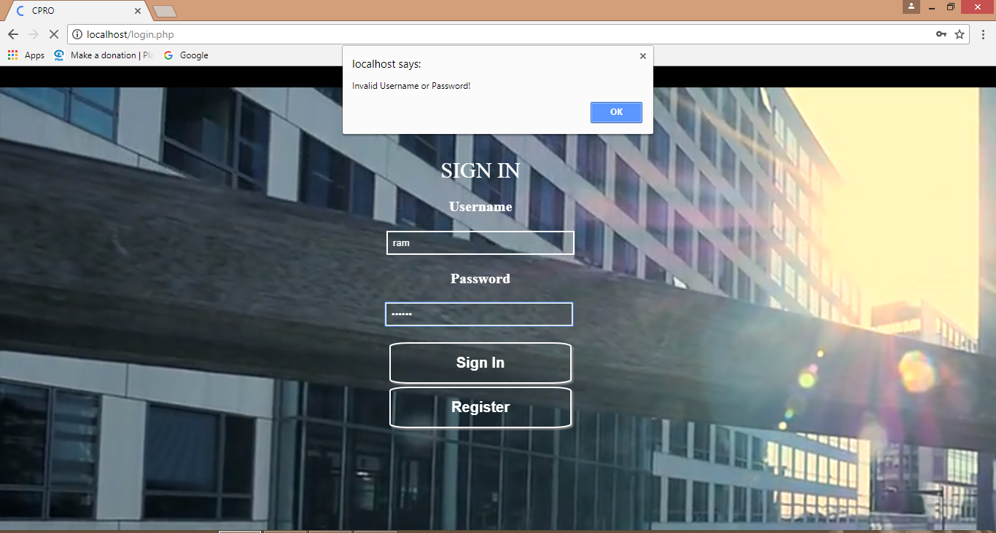

6.1. User login

User Registration

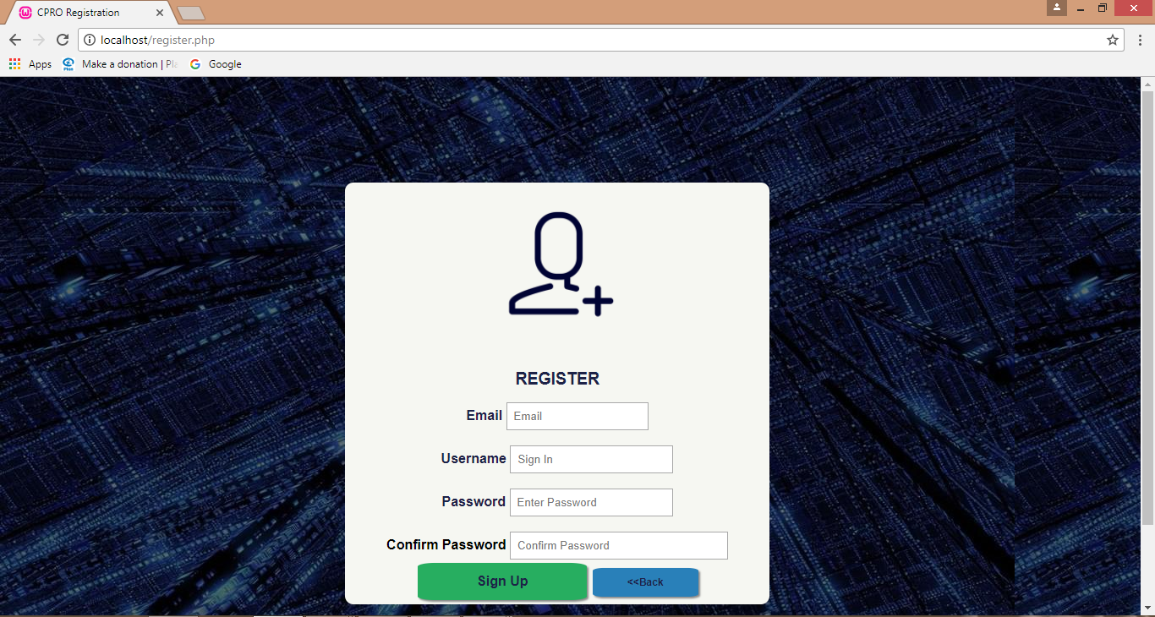

6.1.1.User Registration

User Registration: Successful

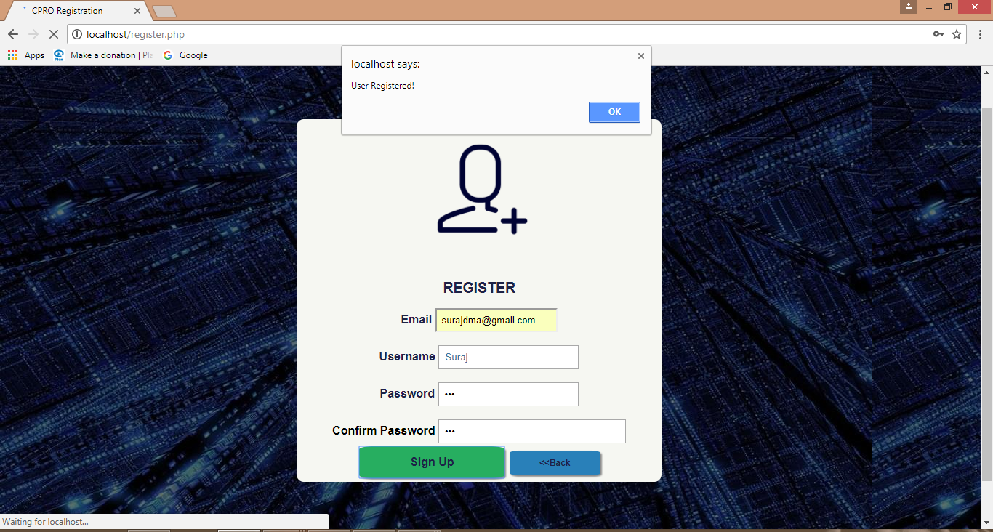

6.1.2.User Registration:Sucessful

User Regiatration: Failure

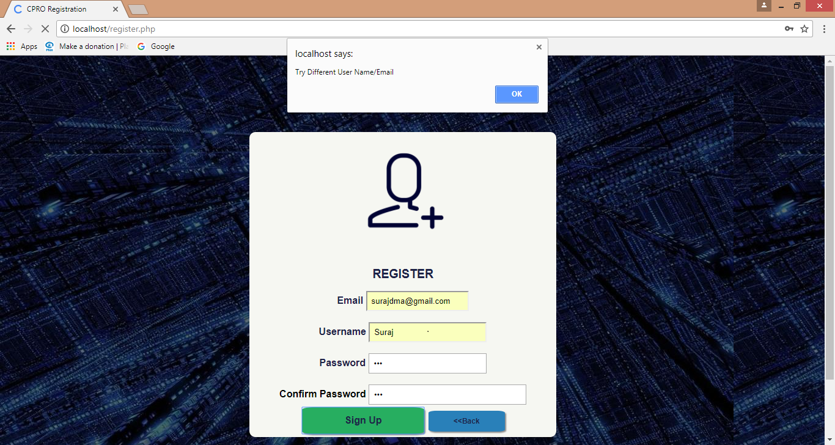

6.1.3.User Registration:Failure

Homepage:

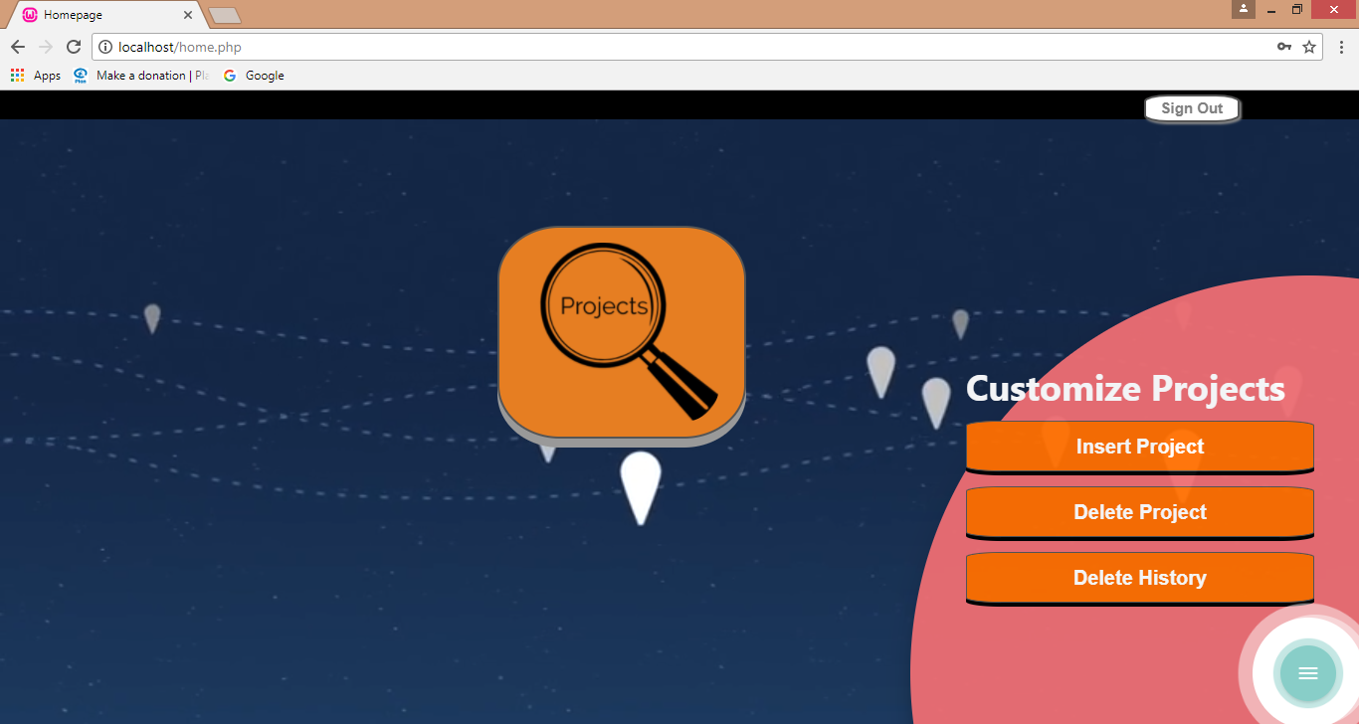

6.1.4.Home Page

Caraousel: All Tables

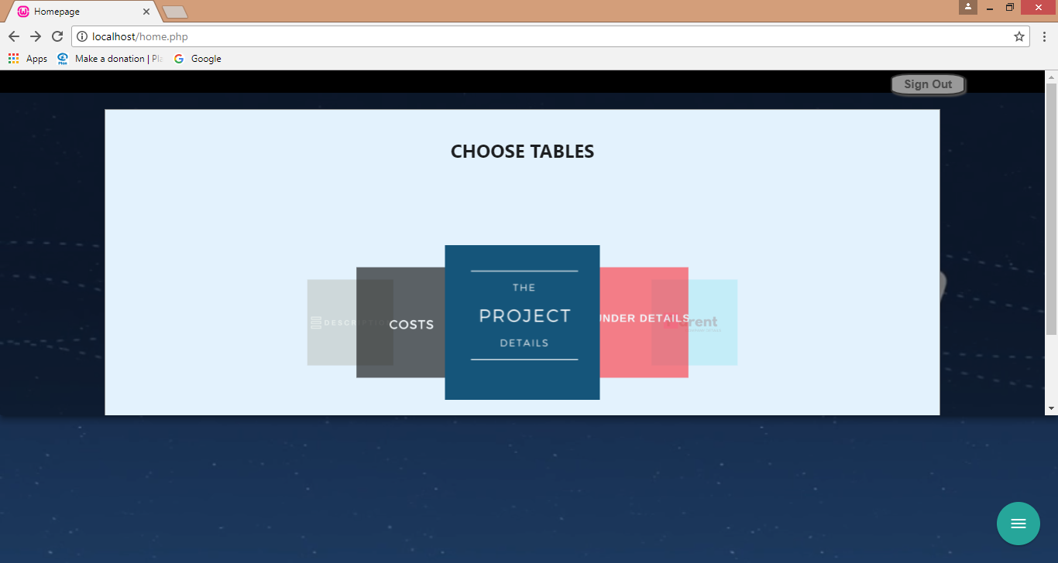

6.1.5.Carousel:All Tables

Insert Project

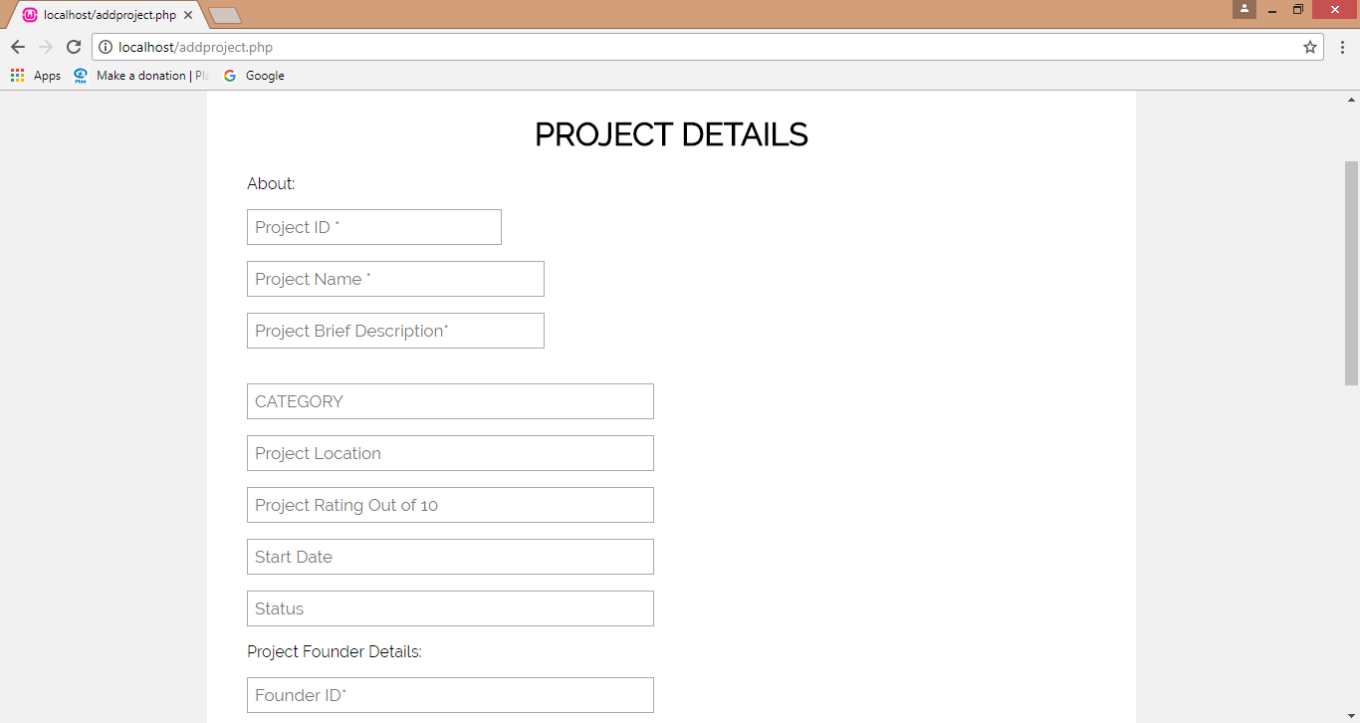

6.2. Insert Project

Delete Project

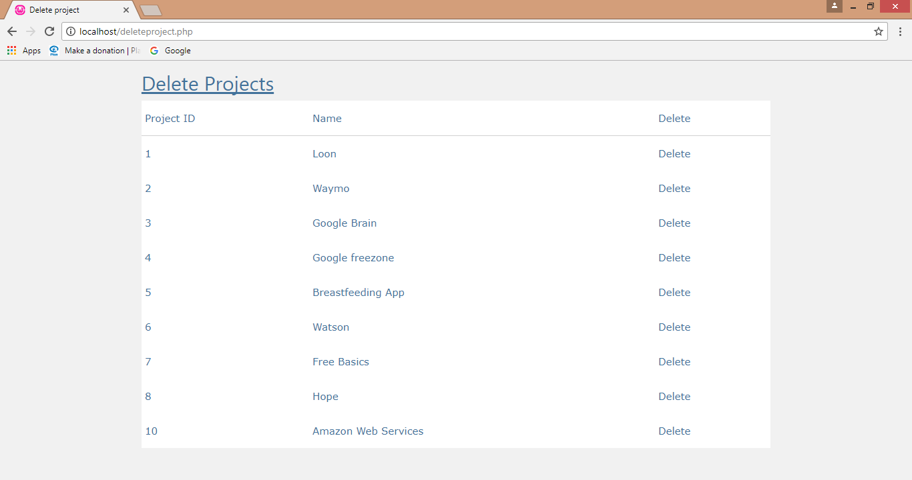

6.2.1. Delete Project

Display Project Details:

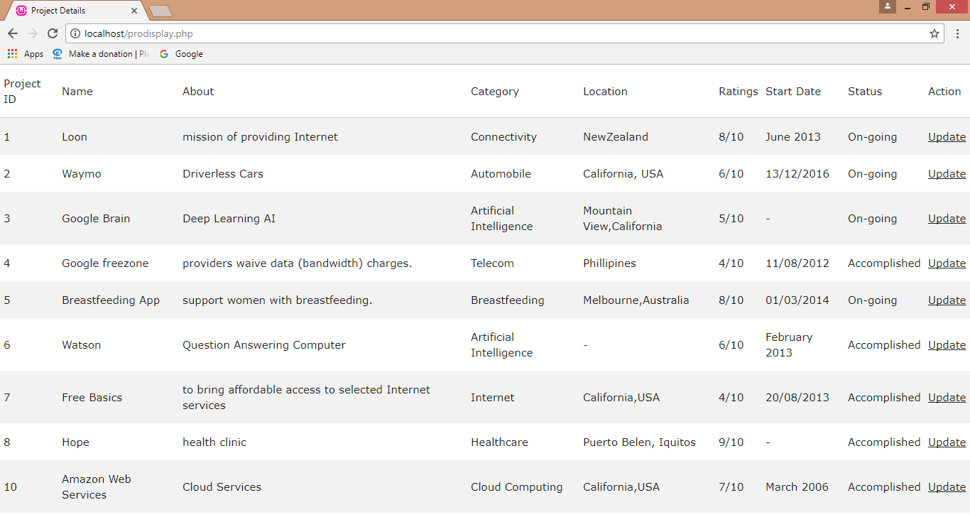

6.2.2 Display Project Details

Update Project Details:

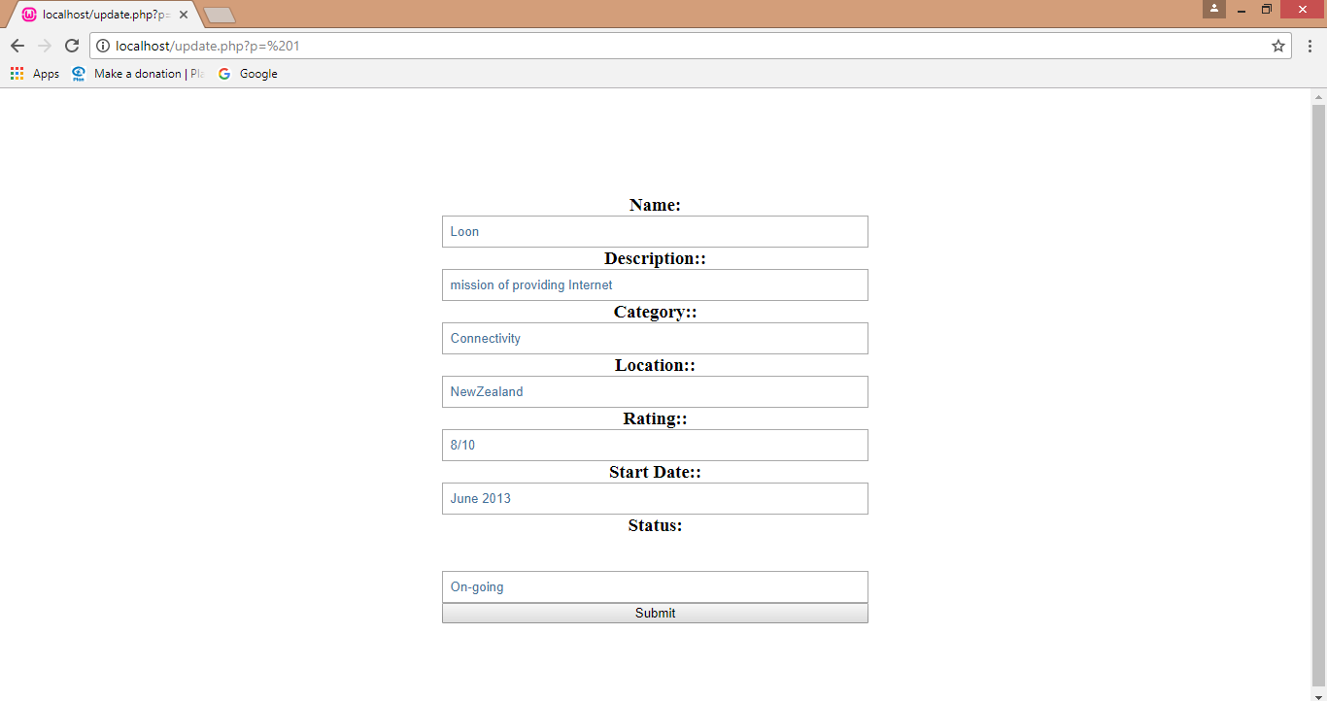

6.2.3 Update Project Details

CONCLUSION

Conclusion:

Company Projects and Analytics Systems keeps track and produces all the data in an efficient and organised manner required for multiple purposes. A Company or an individual keep track of all the on-going and accomplished projects and compute productive analysis from them.

Future scope of the system:

This website has a huge scope for Entrepreneurs and Business Owners as it enable them to record all the necessary data and view them in an efficient manner. In today’s world more and more Companies are turning towards the standardization of the processes. Thus the systematically stored data plays a key role in standardizing the processes. This project has a lot of potential in future to give inputs to any processes so that it can be standardized.

Entrepreneurs can use it and analyse the essential patters of various Companies as the website stores all the relevant information like date, cost, description etc. and make an efficient model for themselves through the data provided by the website.

**BIBLIOGRAPHY**

* During the course of this project reference to the following books and materials were made:

[1] Steven Holzner: PHP the complete references, 5th edition, Tata McGraw Hill, 2007.

[2] Thomas Powell: HTML & CSS, McGraw Hill, 2007.

* Internet was extensively browsed for various materials related to this project

[1] https://www.youtube.com/watch?v=E9MyRFjh8oo

[2] https://www.youtube.com/watch?v=oKDqZCkBRZ8

[3] <https://www.w3schools.com>

[4] http://materializecss.com/